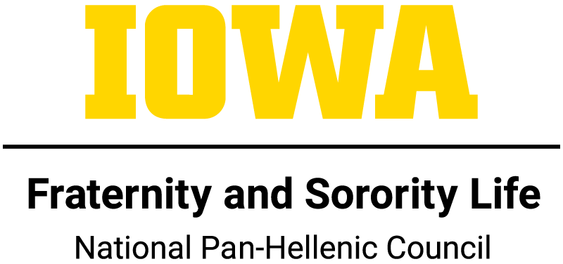
CONSTITUTION OF THE UNIVERSITY OF IOWA

ARTICLE I: NAME
The name of this organization shall be The University of Iowa National Pan-Hellenic Council.

ARTICLE II: PURPOSE
The purpose of the National Pan-Hellenic Council shall be to uphold a collaborative image among all National Pan Hellenic Council organizations on the University of Iowa campus as well as to promote the growth of our respective organizations; and in doing so, maintain positive interfraternal relations at a high level of accomplishment. In pursuit of these goals, the National Pan Hellenic Council shall:

1) Comply with the rules outlined in The University of Iowa Policies and Regulations Affecting students and student organizations.
2) Consider the goals and ideals of member groups as continually applicable to campus and personal life, in cooperation with the overall student body.
3) Promote scholarship as a basis for intellectual achievement.
4) Cooperate with member fraternities and sororities, the university administration, and faculty in concern for and maintenance of high social moral standards.
5) Act in accordance with National Pan-Hellenic Council and policies.
6) Act in accordance with rules established by National Pan-Hellenic Council so as not to violate the sovereignty, rights, and privileges of member fraternities and sororities.

ARTICLE III: ORGANIZATION
Section l. It shall be the duty of the National Pan-Hellenic Council to administer all business related to the overall welfare of chapters and establish governing policies/procedures on the University of Iowa’s campus.

Section 2. The National Pan-Hellenic Council shall be composed of the Executive Board, and one representative from each member fraternity and sorority. These representatives shall be:

The standing committees of the NPHC shall be:
1) Yard Show/OnIowa! Committee
2). Stroll Competition /Step Show Committee

Section 3.. There shall be at least one advisor assigned to the National Pan-Hellenic Council from the Office of Fraternity and Sorority Life Programs.

ARTICLE IV: MEMBERSHIP
Section 1. The membership shall be composed of all National Pan-Hellenic Council fraternities and sororities in good standing with the National Pan-Hellenic Council at The University of Iowa.
1) Governing documents in compliance with University Human Rights Clause
2) In Good Standing with the University
3) Financial on all levels (University & Organization)
4) Each organization must turn documentation into the FSL office/ Exec board as a way of confirming financial status on a yearly basis.
5) Each organization must turn in risk management and intake policies.

Section 2. If an organization of NPHC is not currently on campus, wants to become a recognized student organization they must:

1) Contact the NPHC President
2) Contact the Fraternity and Sorority Life Office
3) Contact the respective national headquarters to ensure proper procedure is followed.

Section 3. If an organization of NPHC previously on campus wants to re-charter and
conduct an intake process they must:

1) Follow the process outlined in Article III Section 3.
2) Ensure all outstanding financial obligations have been paid in full in respect to the University of Iowa.

ARTICLE VII: NPHC EXECUTIVE BOARD
Section 1. The National Panhellenic Executive Board shall be composed of the elected officers of the National Pan-Hellenic Council:
1) President
2) Vice President (Programming)
3) Secretary
4) Treasurer
5) Public Relations/Marketing Chair

Section 2. The officers shall be initiated members, in good standing, of organizations holding membership in the National Pan-Hellenic Council.
- Good standing means that:
I. Current UI undergraduate students;
II. Met the minimum 2.5 cumulative GPA to be elected and must maintain a 2.5 semester GPA
III. Your chapter is financial with the University of Iowa National Pan-Hellenic Council
IV. Your chapter is financial with your national organization.
V. Your chapter must be in good standing with the National Pan-Hellenic Council
VI. Upholding the responsibilities specified in your Officer Contract

Section 3. Officers shall hold a term of office for one year starting at the end of December through the next December.

Section 4. Officers shall be elected by an electoral system where each member chapter has one (1) vote. The one (1) vote shall come from the representative delegate chapter member. These elections shall be open to the entire National Pan-Hellenic Council.

Section 5.Given a quorum, officers shall be elected by a 2/3 vote of the legislative body.

Section 6. Upon voting, if no candidate receives a 2/3 vote, a run-off will take place between the candidates with the top two most votes. The voting chapters are allowed to ask each of the remaining candidates one question (omit sentence). Then there will be a re-vote.

Section 7. In case of tie, the elections shall be decided by the members of the outgoing executive council. Only those members of the outgoing executive council who are not a candidate for the office, may vote.

ARTICLE VI: DELEGATES
Section 1. The representation of the chapter delegate at delegate meetings will occur upon their election by their chapter.
1) At least one delegate will be elected or appointed by each organization.
2) The one representative holds one (1) vote in all legislative matters.

Section 2. Duties
1) Attendance at each legislative meetings.
a. If the delegate is unable to attend chapter must appoint another delegate
2) Provide the council with a chapter report

Section 3. When a delegate vacancy occurs, the fraternity or sorority concerned must select a replacement within two weeks and notify the National Pan-Hellenic Council of the replacement.

1) Contact Council President 24 hours prior legislative meeting
a. If chapter has no representation electronic reports must be sent in weekly

ARTICLE VII: DELEGATE MEETINGS
Section 1. The National Pan-Hellenic Council shall meet on a bi-weekly basis for business throughout the semester at a time and place determined by the National Pan-Hellenic Council at the beginning of each semester. Special meetings may be called by the President when appropriate.

Section 2. All National Pan-Hellenic Delegate meetings shall be open to the entire National Pan-Hellenic Council except for any meetings deemed necessary to be closed at the discretion of the Executive Board.

Section 3. Quorum shall consist of “50% + 1” chapters present at the Delegate meeting.

Section 4. The delegates from each member organization shall be responsible for notifying their chapter of all regular and special meetings of the National Pan-Hellenic Council.

Section 5. The National Pan-Hellenic Executive Board shall meet jointly once per semester or as deemed necessary with the Interfraternity Council (IFC) Executive Board, the Multicultural Greek Council (MGC) and the Panhellenic Council (PHC) Executive Board.

ARTICLE VIII: ATTENDANCE
Section 1. Every chapter is required to have at least one (1) delegate in attendance at every NPHC Delegate meeting, NPHC sponsored events, and FSL required programs. These events include and are not limited to; Leadership Advance, Meet the Greeks, NPHC 101, and other events as deemed required by the NPHC. If a delegate is unable to attend, they must notify the President via email one (1) day prior to the scheduled meeting, with the exception of an emergency.
A. If a chapter fails to have a representative present at any required events stated in Section 1, the chapter will be subject to;
I. First offense ten dollar ($10) fine
II. Second offense fifteen dollar ($15) fine
III. Third offense twenty five dollar ($25) fine and Advisor Meeting
a. NPHC Advisor may state chapter cannot conduct an event

ARTICLE IX: VOTING
Section 1.Each member organization, in good standing, shall have one (1) vote in all National Pan-Hellenic Council matters, unless privileges have been revoked by the Executive Board.

Section 2. The designated delegates, elected by their fraternity or sorority, and registered with the National Pan-Hellenic Council make up the voting body.

Section 3.It shall take a two-thirds affirmative vote to approve all motions concerning the policies/procedures, amendments to the Constitution and By-laws. Notice of such motions must be given at the preceding regular meeting of the National Pan-Hellenic Council in writing by a member of the Executive Board. If a general member would like to propose an amendment please contact the NPHC President.

Section 4. Electronic Voting Permission
I. If the legislative body is unable to find a time to meet in which a quorum can be established, the executive body can host a vote electronically. The electronic vote will be open for twenty four hours and each chapter will have one vote.
II. Elections may also be conducted electronically following this form.

ARTICLE X: VIOLATION
Section 1. Violations of any regulations of this Constitution or its related By-laws and Rules shall be referred to the NPHC President and Advisor, consisting of Executive Board members, for review and any possible sanction deemed necessary by the president and advisor.

ARTICLE XI: HUMAN RIGHTS CLAUSE:
Section 1. The University of Iowa brings together in common pursuit of its educational goals persons of many nations, races, and creeds. The University is guided by the precepts that in no aspect of its programs shall there be differences in the treatment of persons because of race, creed, color, religion, national origin, age, sex, pregnancy, disability, genetic information, status as a U.S. veteran, service in the U.S. military, sexual orientation, gender identity, associational preferences, or any other classification that deprives the person of consideration as an individual, and that equal opportunity and access to facilities shall be available to all. These principles are expected to be observed in the internal policies and practices of the University; specifically in the admission, housing, and education of students; in policies governing programs of extracurricular life and activities; and in the employment of faculty and staff personnel. Consistent with state and federal law, reasonable accommodations will be provided to persons with disabilities and to accommodate religious practices. The University shall work cooperatively with the community in furthering these principles.

